BOX API File Upload Step

Objective

Use the Upload API to allow users to add a new file. The user can then upload a file by specifying the destination folder for the file. If the user provides a file name that already exists in the destination folder, the user will receive an error.

UI

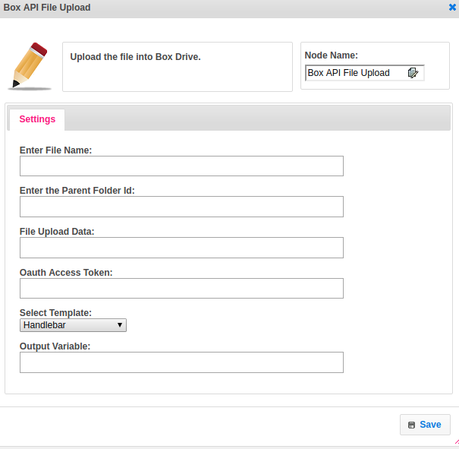

## Attributes

|  |  |
| --- | --- |
| **Attributes** | **Description** |
| **1. Enter File Name** | The name of the file |
| **2. Enter the Parent Folder Id** | The ID of the parent folder. Use "0" for the root folder. |
| **3. File Upload Data** | The ID of the parent folder. Use "0" for the root folder. Type String. |
| **4. Oauth Access Token** | Access tokens are the thing that applications use to make API requests on behalf of a user. The access token represents the authorization of a specific application to access specific parts of a user’s data.  If the request for an access token is valid, the authorization server needs to generate an access token (and optional refresh token) and return these to the client, typically along with some additional properties about the authorization. |
| **5. Select Template** | The template used to set the value type.  Value types are two types.  1.hb-HandleBars  2.ftl-Freemarker Template Language. |
| **5. Output Variable** | Used to store the response of the request. |

## Executor Description

To process Box API file upload step we required Box API file upload end URL. Build the RequestBody object by setting the request body type as a form by setting parent folder id, file name, and a decoded file data.

Build the Request object by sending the end URL, add Header Authorization as key and accessToken as value and pass the RequestBody object to post body.

By executing OkHttpClient newCall(Request req) we can process our request.

## Dependent Plugins

|  |  |
| --- | --- |
| **Attributes** | **Description** |
| Key | Key is nothing but **Client ID**.  The client id is a public identifier for apps. Even though it’s public, it’s best that it isn’t guessable by third parties, so many implementations use something like a 32-character hex string. It must also be unique across all clients that the authorization server handles. If the client ID is guessable, it makes it slightly easier to craft phishing attacks against arbitrary applications. |
| Secret | A secret is nothing but the **Client Secret.**  The client secret is a secret known only to the application and the authorization server. It must be sufficiently random to not be guessable, which means you should avoid using common UUID libraries which often take into account the timestamp or MAC address of the server generating it. A great way to generate a secure secret is to use a cryptographically-secure library to generate a 256-bit value and converting it to hexadecimal representation. |

## Resource

More information about Box API file upload please refer the following link.

<https://developer.box.com/reference#upload-a-file>